Calculating Improvement Value
After verifying if there is a need for time adjustment, the next step is to find the land residual value by deducting the depreciated improvement value from the total value. Since I do have the land value and improvement value for the previous year, I just need to time adjust those values based on the current evaluation date, July 1st, 2017. For this purpose, I run a linear model with no intercept with sale price as dependent variable and assessed values for improvement and land values as independent variables.

Model Summary
Model | R | R Square | Adjusted R Square | Std. Error of the Estimate
1 | .997 | .993 | .993 | 12460

Coefficients
Model  1 |  | Unstandardized Coefficients (B) | t | Sig.
 | Land assessed value (previous year) | 1.02 | 23.74 | .000
 | Improvement assessed value (previous year) | 1.04 | 44.67 | .000

Which implies the following equations:
Time Adjusted Sale Price = (1.02 * landval) + (1.04 * imprval)
The equation shows that to bring the current assessed value to the current time (2017), the land value may be adjusted by 2% and improved value should be adjusted by 4%. The marginal change of values based on time reconfirms our conclusion in the previous section. Based on this regression, we calculate the time adjusted improved value and use it to find the land residual.

Ussing Additive Multiple Regression Model for Land Valuation

Step 1- Model Structure
I am using additive multiple regression model (MRA) with adjusted land valuation as the dependent variable.

Step 2-5- Review Variable and Transform as Necessary
Through a preliminary screening, these are the potential variables that could be used for modeling; I already checked to ensure that we have enough number of observations for each variable.
Variables for Modeling Land Residuals
Land Additive
lot_size_adjusted | Adjusted lot size
Width | Lot width in feet – an additive factor influencing the usability of the land.
Depth | Lot depth in feet – another additive factor influencing lot usability.
Land Qualitative
Corner | Whether the lot is on a corner – qualitative since it describes a specific location attribute.
Culdesac | Whether the lot fronts on a cul-de-sac – qualitative as it impacts desirability but not size directly.
alley | Whether there is a rear alley – qualitative since it adds access benefits.
wooded | Whether the lot is wooded – qualitative and tied to aesthetic or environmental appeal.
pie_shpe | Whether the lot is pie-shaped – qualitative, describing the shape which may impact value.
slope | Whether the lot has a slope of 12%-30% – qualitative, indicating potential construction challenges or advantages.
abv_road | Whether the lot is above the road – qualitative, linked to view or drainage advantages.

For each of the variable above, I analyzed the relationship between the response variable (land residual) and the variable by either scatter plot or box plot and include the results in the appendix (Figure A.3 – Figure A.11). Based on the results, `adjusted lot size` has almost perfect linear relationship with the land residual; `width` has a positive effect, and `depth` does not seem to have significant effect. Also, except `wooden` and `abv_road`, other land qualitative seems to be correlated with land residual.
Before, we chose our final selection for the variables, we examine the effect of Neighborhood on the land residual. Table blow summarizes the land residual price for various neighborhoods.
Average land residual for each neighbourhood
Sub neighborhood | N | Mean | Std. Deviation
713 | 87 | $ 46,876 | 9699.5
715 | 59 | $ 47,371 | 11467.9
716 | 146 | $ 64,684 | 12511.7
731 | 29 | $ 56,648 | 12481.4
732 | 8 | $ 60,911 | 17568.5
734 | 12 | $ 42,187 | 9109.9
736 | 27 | $ 48,417 | 12016.8
737 | 78 | $ 63,639 | 15093.3

As the table shows, neighbourhood 716 has the greatest number of sales and so it could be considered as the base for our analysis. Lastly, we should examine the correlation between the independent variables. As it is shown in the appendix, there does not appear to be a correlation between variables selected so far.

Step 6 – List a Final Group of Potential Variables
So far, I conclude the following list of variables: `lot_size_adjusted`, `width`, `depth`, `corner`, `culdesac`, `alley`, `pie-shpe`, and `slope`. Using stepwise regression analysis (function step in R), the following steps are followed:
Stepwise Regression Analysis
Model | R Square | Adjusted R Square | Std. Error of Estimate | F Statistics | Sig
1 | 0.388 | 0.370 | 11,800 | 21.06 | 0.000
2 | 0.388 | 0.371 | 11,790 | 22.87 | 0.000
3 | 0.388 | 0.372 | 11,770 | 25.00 | 0.000
4 | 0.388 | 0.374 | 11,760 | 27.53 | 0.000
5 | 0.386 | 0.374 | 11,760 | 30.50 | 0.000
6 | 0.385 | 0.374 | 11,760 | 34.23 | 0.000
7 | 0.384 | 0.374 | 11,750 | 39.03 | 0.000
- Predictors: width + corner + culdesac + alley + pie_shpe + slope + neigh_713 + neigh_715 + neigh_736 + neigh_731 + neigh_737 + neigh_734 + neigh_732
- Predictors: width + corner + culdesac + pie_shpe + slope + neigh_713 + neigh_715 + neigh_736 + neigh_731 + neigh_737 + neigh_734 + neigh_732
- Predictors: width + corner + culdesac + pie_shpe + neigh_713 + neigh_715 + neigh_736 + neigh_731 + neigh_737 + neigh_734 + neigh_732
- Predictors: width + corner + pie_shpe + neigh_713 + neigh_715 + neigh_736 + neigh_731 + neigh_737 + neigh_734 + neigh_732
- Predictors: width + corner + neigh_713 + neigh_715 + neigh_736 + neigh_731 + neigh_737 + neigh_734 + neigh_732
- Predictors: width + corner + neigh_713 + neigh_715 + neigh_736 + neigh_731 + neigh_734 + neigh_732
- Predictors: width + corner + neigh_713 + neigh_715 + neigh_736 + neigh_731 + neigh_734

Coefficients for the final model are obtained as below:
Model Coefficients
Covariates | Coefficients | Std. Error | t | Sig | VIF
(constant) | 44025.2 | 3058.9 | 14.392 | 0.000
width | 316.5 | 47.4 | 6.677 | 0.000 | 1.039
corner | 2325.9 | 1559 | 1.492 | 0.136 | 1.014
neigh_715 | -16449.9 | 1715.8 | -9.588 | 0.000 | 1.091
neigh_736 | -16319.7 | 2392.4 | -6.821 | 0.000 | 1.051
neigh_731 | -7971.6 | 2317.4 | -3.44 | 0.000 | 1.054
neigh_734 | -21342.6 | 3487.1 | -6.12 | 0.000 | 1.028
neigh_713 | -15826.7 | 1495.2 | -10.585 | 0.000 | 1.133

Step 7-8 – Model Calibration and Testing
The output for the regression analysis is given by the table above and therefore, I only show the residual statistics here. Next, I ran Casewise Diagnostic test and there is a case with Std. Residual less than -3 which needs to be addressed. There are two sales both at Neigh 737 with sale prices $117,199 and $135,721 that have standard residual of less than -3. I remove these two and repeat the model coefficients and residual statistics.
Residuals Statistics
 | Minimum | Maximum | Mean | Std. Deviation | N
Predicted Value | 37692.85 | 80451.87 | 56556.95 | 9209.648 | 446
Residual | -36936.61 | 34012.13 | 0.00 | 11661.05 | 446
Std. Predicted Value | -2.05 | 2.59 | 3.33 | 1.00 | 446
Std. Residual | -3.17 | 2.92 | 0.00 | 1.00 | 446

The modified coefficients for the final model are provided below:

Model Coefficients – Revised Model after Casewise Diagnosis
Covariates | Coefficients | Std. Error | t | Sig | VIF
(constant) | 44923.63 | 3001.73 | 14.966 | 0.000
width | 307.64 | 46.45 | 6.623 | 0.000 | 1.039
corner | 2167.81 | 1526.91 | 1.42 | 0.156 | 1.014
neigh_715 | -16779.9 | 1681.6 | -9.979 | 0.000 | 1.092
neigh_736 | -16629.7 | 2343.61 | -7.096 | 0.000 | 1.051
neigh_731 | -8275.85 | 2270.15 | -3.646 | 0.000 | 1.055
neigh_734 | -21673.2 | 3415.3 | -6.346 | 0.000 | 1.028
neigh_713 | -16189.8 | 1466.25 | -11.042 | 0.000 | 1.135

Residuals Statistics
 | Minimum | Maximum | Mean | Std. Deviation | N
Predicted Value | 37963.12 | 80333.43 | 56712.31 | 9392.669 | 444
Residual | -31524.2 | 33605.79 | 4.667222 | 11586.71 | 444
Std. Predicted Value | -2.01165 | 2.537033 | 0.001178 | 1.008354 | 444
Std. Residual | -2.76095 | 2.943255 | 0.000409 | 1.014785 | 444

Where no outlier for the residuals is observed anymore.
To ensure consistent prediction over various variables, I run K-W test to see if there is a significant difference between Land residual and Land residual prediction for different neighbourhoods.
Average land residual for each neighbourhood and K-W test
Neigh | N | Mean Rank
713 | 87 | 228.8046
715 | 59 | 219.5254
716 | 146 | 225.0068
731 | 29 | 214.1724
732 | 8 | 181.375
734 | 12 | 218.4167
736 | 27 | 228.5556
737 | 76 | 218.7763

 | Ratio
K-W H | 1.378
Df | 7
Sig | 0.986

The K-W test above shows that there is not evidence for a significant difference between neighborhoods and the land residual prediction. This observation is confirmed by the table below which is Ratio Statistics for the ratio between land residual and land residual prediction.

 |  | 95% CI for Median
Group | Median | Lower Bound | Upper Bound | Actual Coverage | Min | Max | COD
713 | 1.00 | 0.96 | 1.05 | 95.31 | 0.52 | 1.63 | 15.48
715 | 1.00 | 0.94 | 1.05 | 95.31 | 0.58 | 1.56 | 17.64
716 | 1.00 | 0.98 | 1.03 | 95.31 | 0.6 | 1.54 | 14.17
731 | 1.00 | 0.92 | 1.08 | 95.31 | 0.58 | 1.42 | 17.71
732 | 0.94 | 0.75 | 1.13 | 95.31 | 0.64 | 1.32 | 24.32
734 | 1.00 | 0.9 | 1.1 | 95.31 | 0.71 | 1.41 | 13.32
736 | 1.00 | 0.91 | 1.09 | 95.31 | 0.37 | 1.58 | 17.33
737 | 1.00 | 0.95 | 1.04 | 95.31 | 0.55 | 1.51 | 15.3

The table shows that the confidence interval for all neighborhoods bracket 1.00 which again confirm that there is no evidence for a significant difference between the neighborhoods. Also, all CODs are less than the threshold of 25% for vacant land. Therefore, we have now our final model for land value.
Land_residual_predict = 44923.63 + 307.64 x width 2167.81x corner -16779.3 x neigh_715
-16629.74 x neigh_736 -8275.85 x neigh_731 -21673.2 x neigh_734 -16189.8 x neigh_713

Calculating Land Residual

Fig A 1
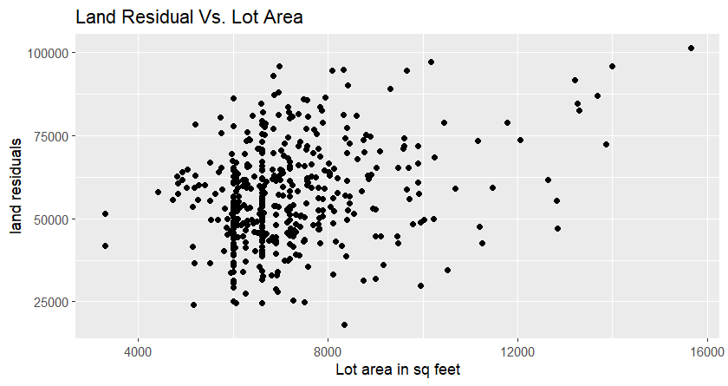

Fig A 2
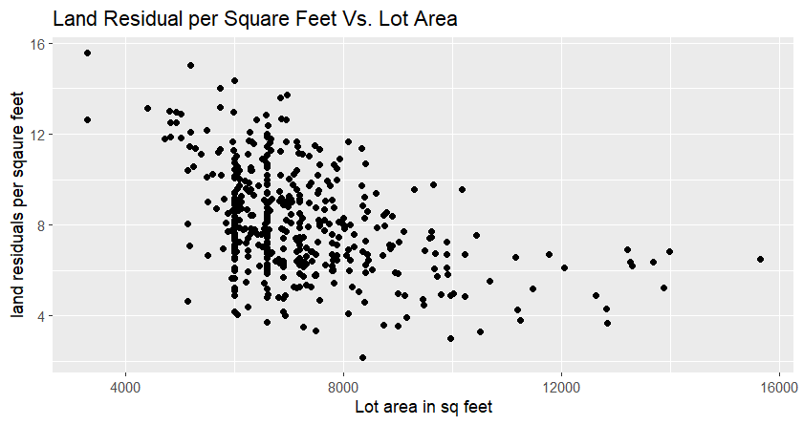

Step 2-5- Review Variable and Transform as Necessary – Scatter and Box plots

Fig A 3 Fig A 4
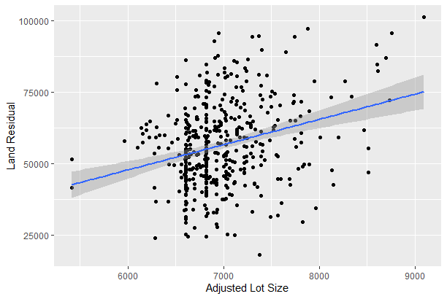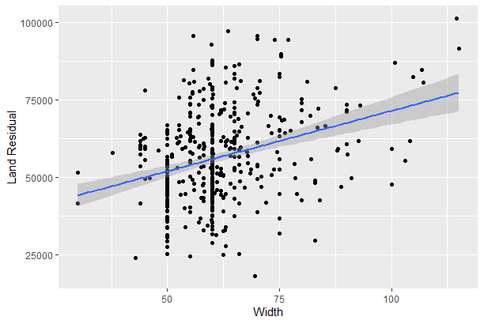

Fig A 5 Fig A 6
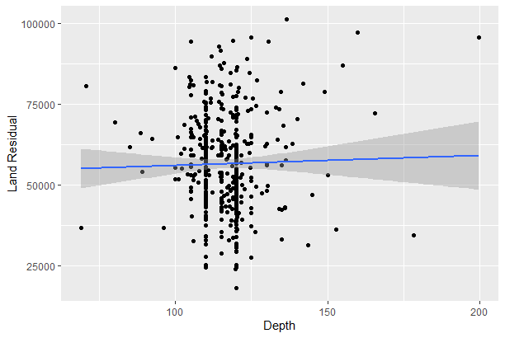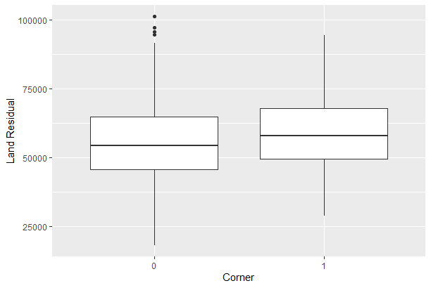
Fig A 7 Fig A 8
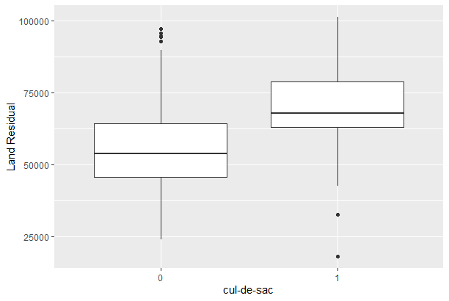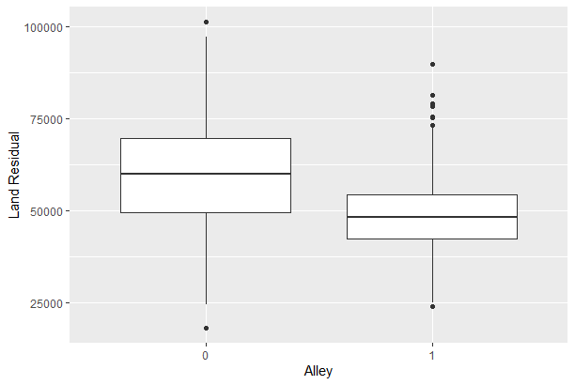
Fig A 9 Fig A 10
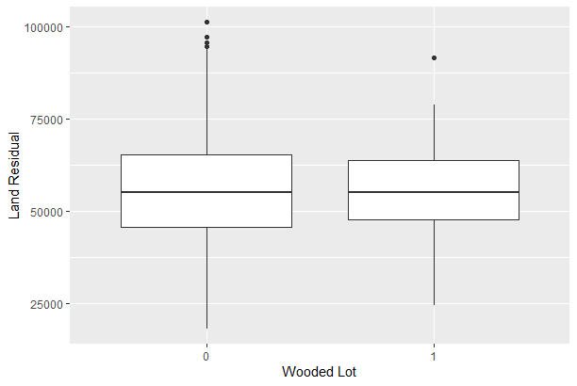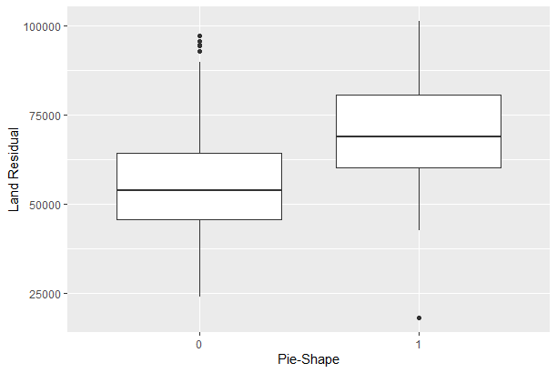
Fig A 11 Fig A 12
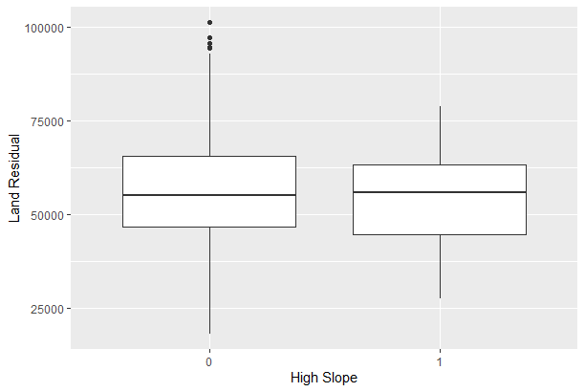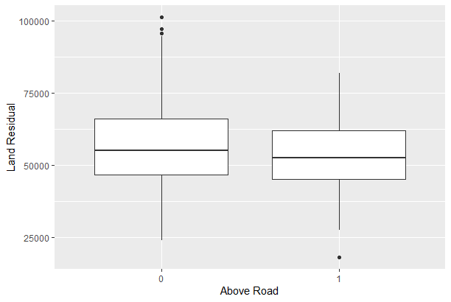

Step 2-5- Review Variable and Transform as Necessary – Correlation Matrix
 | lot_size_adjusted | width | corner | culdesac | alley | pie_shpe | slope
lot_size_adjusted | 1.00 | 0.31 | 0.07 | 0.19 | -0.33 | 0.20 | -0.06
width | 0.31 | 1.00 | 0.09 | 0.32 | -0.16 | 0.33 | -0.11
corner | 0.07 | 0.09 | 1.00 | -0.09 | -0.05 | -0.03 | -0.07
culdesac | 0.19 | 0.32 | -0.09 | 1.00 | -0.16 | 0.44 | 0.01
alley | -0.33 | -0.16 | -0.05 | -0.16 | 1.00 | -0.15 | -0.05
pie_shpe | 0.20 | 0.33 | -0.03 | 0.44 | -0.15 | 1.00 | -0.10
slope | -0.06 | -0.11 | -0.07 | 0.01 | -0.05 | -0.10 | 1.00

